**1. Abstract**

The global energy system is transforming with the consideration of a growing population with rising living standards that will need more energy. Simultaneously, the world must find ways to reduce greenhouse gas emissions and provide sustainable energy production. As electricity is the fastest-growing part of the energy system and thus shifting to renewable energy production systems is the need of the hour. IEA reports that the Sun could be one of the largest resources for energy production for the upcoming ‘net zero goals’ of the world. Rapid decrease in the cost of installation and availability of solar radiation are major advantages for adoption, although this mode of generation of energy has a variable output which is influenced by several parameters. Hence solar energy forecasting is crucial to understand and predict the output of production, the demand of the consumers, and optimizing the dispatch of the electricity from grids to users. In this paper, we have analyzed innovative methodologies for forecasting solar energy radiation. Moreover, it provides a review and comparative analysis on various ANN, Probabilistic and Statistical, and Time Series based models used for estimating solar irradiation. Each of these models have been trained and tested in different geographical regions, weather conditions, and corresponding relevant parameters, which would provide an insight on efficient model selection and optimization for predicting short and long-term solar irradiation. Further, we have discussed some challenges while forecasting solar irradiation and future research direction in this domain.

Keywords: solar irradiation, solar energy, AI models,analysis,ANN,Statistical, Probabilistic , Time series, short and long term forecasting

**2. Abbreviations**

| Abbreviation | Full - form |
| --- | --- |
|  |  |
| AI | Artificial Intelligence |
| ANFIS | adaptive-network-based fuzzy inference system |
| ANN | Artificial Neural Network |
| ARIMA | autoregressive integrated moving average |
| ARMA | Auto Regressive Moving Average |
| ARMAP | autoregressive moving average process |
| DBN | deep belief network |
| DNN | Deen Neural Network |
| DT | Decision Tree |
| HELmanNN | Elman Neural Network |
| ELMNN | Extreme Learning Machine Neural Network |
| GBM | Gradient Boosting Machine |
| GHI | Global Horizontal Irradiation/Irradiance |
| GRNN | general regression neural network |
| GTI | Global Tilted Irradiation/Irradiance |
| LSTM | Long Short-Term Memory |
| MABE | Mean Absolute Bias Error |
| MAE | Mean Absolute Error |
| MAPE | Mean Absolute Percentage Error |
| ML | Machine Learning |
| MLP | Multi-layer Perceptron |
| MSE | Mean Squared Error |
| NARX | nonlinear autoregressive model which has exogenous inputs |
| PV | Photovoltaics |
| RF | Random Forests |
| RMSE | Root Mean Squared Error |
| SSE | Sum of Squared Errors |
| TDNN | Time delay neural network |
| WVC FM | Weight-Varying Combination Forecast Mode |
| XGBR | XGBoost Regressor |

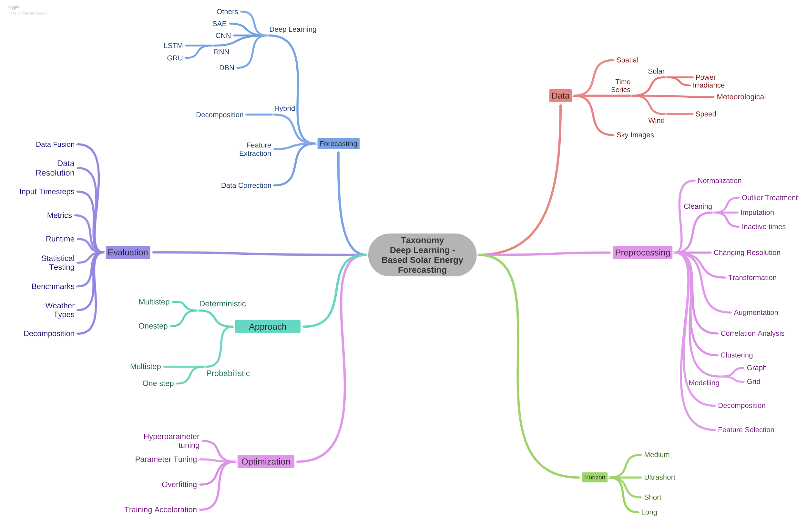

**3. Introduction**

Solar Panels are made of numerous semiconductor cells in an array, which when struck by photons from the Sun would knock electrons loose from their atoms. Conductors of electricity are provided at the sides of these cells which collect electrons and transfer them to wires. The solar inverter then converts DC electricity from solar modules to AC electricity, which is used by appliances. Excess electricity is then fed back to the grid. There are some alternatives to Photovoltaic solar energy generation, such as solar thermal systems, concentrated solar power, and passive solar gain.

A major concern around the solar energy production systems is the variability and unpredictability of environmental factors and other parameters it depends on. This poses issues with the grid reliability and expenses associated with operating the technical infrastructure.Moreover, peak demands and user consumption patterns are uncertain. Therefore, solar energy forecasting addresses this issue by developing models to predict the energy demand, production and irradiation from the Sun. Forecasting systems can help regulate PV systems and determine the dispatching of the energy created.

In this paper, we will particularly focus on Photovoltaic solar systems and the comparative analysis of methodologies used for forecasting solar irradiation. Below listed are the considered parameters for data collection and model training.

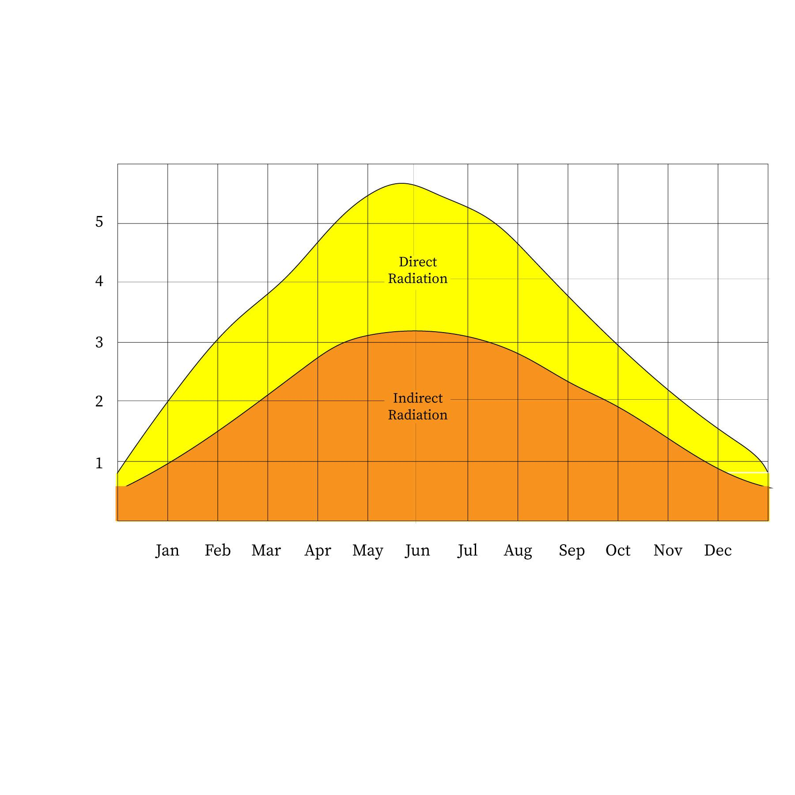

2.2 Parameters

* Temperature(C) - Temperature of the environment around the solar panels' installation. Temperature increase causes the bandgap of semiconductors to diminish, affecting its material properties. Moreover, the open-circuit voltage is the characteristic in a solar cell that is most impacted by temperature changes.
* Humidity(mm)- The amount of solar radiation is influenced by the atmosphere's relative humidity level since increased water vapor concentration produces an increase in reflected refractive radiation. The intensity of the solar radiation absorbed by the photovoltaic cell is lowered in this scenario, which is reflected in the cell's productivity.
* Clear sky index - Cloud cover affects the solar radiation reaching the solar panels, and this index estimates atmospheric attenuation due to clouds by measuring the ratio of surface solar radiation G to the solar radiation that would be received under a clear(cloudless) sky, Gcs.
* Wind speed(m/s)- There is an anticorrelation between wind speed and solar irradiation, and the wind speed range varies according to the geographical location and weather conditions.
* The angle of incidence(ω) - The solar incidence angle is the angle between the sun's rays and the normal on the horizontal surface.
* Azimuth angle(φ) - This is the angle between the projection of syn’s center onto the horizontal plane and due south direction.
* Zenith angle(Z)- This is the angle between the sun and the vertical.
* Atmospheric pressure(atm) - The pressure produced by the weight of air in the Earth's atmosphere is known as atmospheric pressure, and the weight of air is gravitational. This force increases as altitude decreases, exerting a stronger downward pull on the photons, raising solar intensity and the output current and voltage.
* Albedo - This is the amount of light reflected by a surface as is a crucial metric to determine the material of semiconductors in the solar panels. Moreover, the surroundings of the solar panels can diffuse solar radiation, and hence this effect can affect the performance of solar cells.
* Solar insolence(kWh/m^2) - Solar insolation is the measure of solar radiation incident upon a unit horizontal surface over a specified time for a given locality. It depends strongly on the solar zenith angle and also on the ratio of the actual distance to the mean distance of the Earth from the Sun. (S=solar constant, Zenith angle).
* Tilt angle(α) - The angle of tilt of the solar panels is the tilt angle which is largely determined by the latitude values of the location of the solar panel.
* Terrain Elevation(m) - Higher altitudes plants with optimum conditions result in efficient solar energy production than at sea levels.
* Solar irradiance(W/m^2) - This is output power per unit area received from the Sun in the form of electromagnetic radiation in photons.
* Global Horizontal Irradiance(W/m^2)- GHI is the total amount of shortwave radiation received from above by a surface horizontal to the ground. This value includes the Direct Normal Irradiance (DNI) and Diffuse Horizontal Irradiance (DIF). DNI is solar radiation that comes perpendicular to the surface from the direction of the sun. DIF is solar radiation that does not arrive on a direct path from the sun but has been scattered by molecules and particles in the atmosphere.

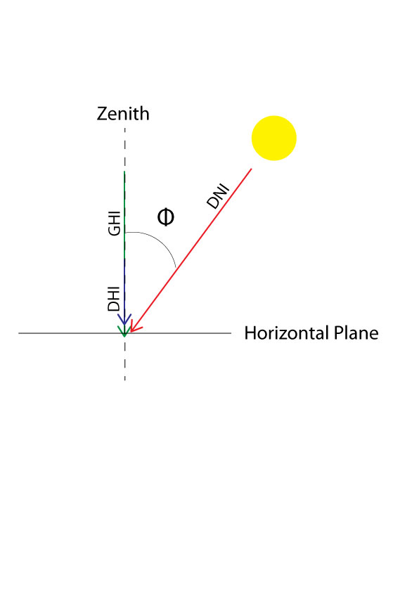

* Size of PV installation(kW) - These can be broadly categorized as small residential, medium and commercial, ground-mounted, and floating large-scale solar panel systems.

Multiple pre-processing techniques can be used for prediction of solar radiations. Some of them discussed in the comparative analysis are :

2.3 Pre-processing Techniques

* Imputation **:**

It refers to filling up missing values in the dataset. The most commonly used technique for imputation is Interpolation. It is used to increase the size of the dataset keeping in mind the dimensionality, and the variance of the data. This is a very crucial step as ML modelling is only possible on data with same dimensionality

* Normalization (min-max scaling) :

In this pre-processing technique, the data points are scaled to unit vectors and the data range is shifted between 0 and 1. It is done to prevent some features with larger variance overshadow the ones with smaller variance during the ML modelling.



* One-Hot-Encoding :

One-hot encoding is a common approach for dealing with categorical data in machine learning. Categorical variables must be converted in the pre-processing section since many machine learning models need numeric input variables.

* Aggregation :

It is a very important pre-processing technique in ML modelling. The most used types of aggregation are :

* Mean : It gives us a central tendency of the data.
* Median : It gives us the central tendency of sorted data.
* Mode : It gives us the category having the highest frequency count.

* PCA :

It is a dimensionality reduction technique used for training conventional ML models. The transformed lower dimensions give an abstract representation of the variance of the data. It is based on the concept of Diagonalization and Eigen Value Decomposition.

* Wavelet Transform :

It is a pre-processing technique similar to the Fourier transform (or much more to the windowed Fourier transform), but with a completely different merit function. The major distinction is that the Fourier transform decomposes the signal into sines and cosines, or functions localised in Fourier space; on the other hand, the wavelet transform utilises functions localised in both real and Fourier space.

There are multiple metrics used to measure the performance of an ML model on the testing data. Some of the important metrics are :

2.4 Performance Metrics

* MSE :

The average of the squares of the errors—that is, the average squared difference between the estimated values and the actual value—is measured by the mean squared error or mean squared deviation of an estimator. MSE is a risk function that represents the squared error loss's anticipated value.

* RMSE :

The root-mean-square deviation, also known as root-mean-square error, is a commonly used metric for comparing values predicted by a model or estimate to values observed.

* MAE :

It is the average of all the absolute errors or alternatively the difference between two given continuous variables.

* MAPE :

In statistics, the mean absolute % error, also known as mean absolute percentage deviation, is a measure of a forecasting method's prediction accuracy.



* R - Squared :

The coefficient of determination, abbreviated as R2 or r2 and pronounced "R squared," is the percentage of variance in the dependent variable that can be predicted by the independent variable.

* Correlation Index

The Pearson product-moment correlation coefficient, often known as Pearson's r, is a measure of linear correlation between two sets of data.

r =

* Kurtosis

Kurtosis is a measure of how "tailed" a real-valued random variable's probability distribution is.

* Phillips perron test

The Phillips–Perron test is a unit root test. In time series analysis, it is used to test the null hypothesis that a time series is integrated of order one.

* Jacques-bera test

The Jarque–Bera test determines if sample data contain skewness and kurtosis that are similar to a normal distribution.

= n

where,

**4. Comparative Analysis**

Quej et al. [1], worked on predicting daily global solar radiation at Yucatán Peninsula, Mexico. The data required for training ML models was collected from Mexican National Meteorological Service and Instituto Nacional de Investigaciones Forestales Agrícolas y Pecuarias (INIFAP).

Yadav & Sethy [2], presented methods for predicting solar irradiation for the USA. The dataset used was collected by the National Renewable Energy Laboratory, USA

The research by Suyono et al. [3], compared the Solar Radiation Intensity predicted by ANFIS and MLR for Basel City, Switzerland. The dataset used for the study was taken from NASA Meteoblue Climatology website

Alqudah et al. [4], worked on Prediction of Solar Radiation Based on Spatial and Temporal Embeddings for San Antonio, Texas. The National Solar Radiation Database was used for training ML models.

Ivanova et al. [5], proposed the usage of NARX Model for Solar Radiation Prediction at Barcelona. The data was provided by an industrial company located in Northern Barcelona.

Gupta & Singhal [6], worked on Prediction of Global Solar Radiation of Pune, India. The data for the research was collected from the Indian Meteorological Department, Pune (IMD,Pune).

Noriega-Angarita et al. [7], proposed methods for Solar Radiation Prediction for Dimensioning Photovoltaic Systems. The data collection was carried out at Columbia weather stations in the Atlantic Coast of Columbia.

Works by Madugu et al. [8], focused on Solar radiation prediction for household purposes. The study was completed in Kano city of Nigeria. The dataset provided by the Nigerian Meteorological Agency (NiMet) was used in ML modelling.

Bendali et al.[9] studied the comparison of models with genetic algorithms by using the Time series data from the solar plants at Fes, Morocco for hourly forecasting of solar irradiation.

Ali-Ou-Salah et al.[10] proposed a new hybrid model for predicting one hour-ahead global solar radiation in the city of Evora located south of Portugal. The weather data is collected from Evora city’s meteorological station using the Eppeley Pyranometer.

Alsharif et al.[11] study aimed to develop a new model for forecasting solar irradiation whose data is obtained from the Korean Meteorological Administration over a span of daily and monthly average prediction output.

Liu et al.[12] studied the short term forecasting of solar irradiation and analyzed its uncertainties by using historical data from the PV power plant located in Ashland, US.

Ghimire et al. [13] proposed the design of a deep learning model from NASA’s GIOVANNI repository of the MODIS satellite and the land observed solar irradiation values were fetched from the Long Paddock SILO database that cover 4 of Australia’s solar cities to forecast long term solar irradiation.

Malvoni et al.[14] developed a hybrid Time series model for daily prediction of solar irradiation from the data acquired from PV systems from University of Salento,Italy.

Urrego-Ortiz et al.[15] worked on day-ahead forecasting of hourly solar irradiation with the data provided from SIATA station located in Medellin,Colombia.

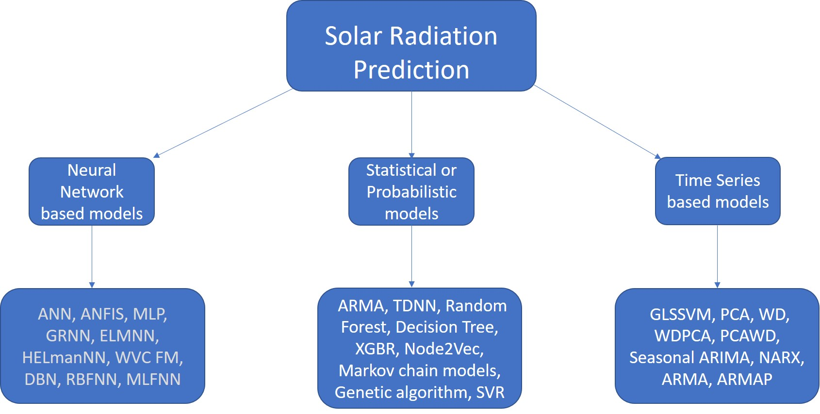

Neural Network based models

| Research Paper cite | Targeted Radiation | Forecast  period | Approach | Performance |
| --- | --- | --- | --- | --- |
| Yadav et al. [2] | Solar Irradiation | 5 days  average | ANN, NWP,  Satellite Imaging,  MLP | MSE = 0.0355 |
| Suyono et al. [3] | Solar radiation | Hourly,  Daily,  Monthly | ANFIS, MLP | ANFIS better ;  RMSE=131.68;  MAE = 95.60 |
| Gupta & Singhal [6] | Global radiation | Monthly | ANN | RMSE : 0.5;  R-Squared: 0.86 to 0.93 |
| Noriega-Angarita et al. [7] | Global radiation | Monthly | ANN | Correlation Index (r) = 0.7 |
| Liu et al. [12] | Global radiation | Hourly | GRNN, ELMNN,  ELmanNN, WVCFM | WVCFM best  R^2= 0.9512  MAPE=6.05%-7.07%  for all weather types |
| Ghimire et al. [13] | Global radiation | Monthly | DBN, XGBR,RF,GBM,  DT,DNN,ANN | DBM best;  RMSE=0.609  MAE=0.5 |

Statistical / Probabilistic models

| Research Paper cite | Type of  Solar energy | Forecast period | Pre-processing | Approach | Performance |
| --- | --- | --- | --- | --- | --- |
| Quej et al. [1], | Global solar  radiation | Daily | Interpolation  imputation | Sine wave formula,  Cosine wave formula,  Gaussian formula | Gaussian formula is  best estimator;  R2=0.868,  RMSE=1.191 ,  MBE=0.006,  MABE=0.928 ,  MPE=-0.385%,  MAPE=5.09 % |
| Alqudah et al. [4] | Solar radiation  based on  spatio-temporal  embeddings | Seasonal | Min-max scaling  (Normalization),  missing value removal,  1-hot encoding | ARMA, TDNN,  Random Forest,  Node2Vec | Random Forest best;  R-Squared for summer=0.91,  winter=0.85, global=0.89 |
| Bendali et al. [9] | Solar irradiation | Hourly | Stationary, historical  lag identification,  normalization,  wavelet transform,  self-organizing map | RNN, LSTM,  GRU + Genetic Algorithm | LSTM-GA best ;  MSE=0.0015 ,  MAE = 0.027 |
| Ali-Ou-Salah et al. [10] | Solar radiation | Hourly | Not mentioned | ANN,GB, Daily  Classification  technique + SVR, RF | Daily Classification technique  + SVR, RF best;  SVR + Daily classification  RMSE(sunny)=38.8,  MAE(sunny)=19.72 ;  RMSE(cloudy)=87.05,  MAE(cloudy)=25.37  RF + Daily classification  RMSE(sunny)=39,  MAE(sunny)=21.03 ;  RMSE(cloudy)=85.77,  MAE(cloudy)=50.19 |
| Urrego-Ortiz et al. [15] | Solar irradiation | Hourly | normalization | Markov chain models  Persistence based,  2 chain Markov model | 2 chain Markov model best;  RMSE=214  MBE=33.9 |

Time - Series Models

| Research Paper cite | Type of Solar energy | Forecast period | Pre-processing | Approach | Performance |
| --- | --- | --- | --- | --- | --- |
| Ivanova et al. [5] | Solar radiation | Hourly | Pre-processed data | NARX | MSE = 0.0348,  MAE = 0.1360,  RMSE = 0.1864 |
| Madugu et al. [8] | solar radiation | Daily | Taking aggregation (mean)  of daily data | ARMA,  ARMAP | ARMAP is better;  RMSE < 0.0004;  SSE < 0.03885 |
| Alsharif et al. [11] | solar radiation | Daily ;  Monthly | the removal of outliers ,  treatment of zero readings,  interpolation of missing data | Seasonal  ARIMA | RMSE(monthly) = 33.18,  R^2(monthly)= 79%  RMSE(daily) = 104.26 ;  R^2(daily) = 68% |
| Malvoni et al. [14] | solar radiation | Daily | wavelet decomposition ,  Principal Component Analysis | GLSSVM ,  PCA, WD,  WDPCA ,  PCAWD | GLSSVM performs best |

**5. Other Literature Review and Findings**

Ensemble approaches have been a key enhancement in terms of prediction accuracy and have grabbed the attention of many researchers . For example, AlKandari et al.[16] proposed an architecture of model wherein LSTM model and a statistical model such as the Theta model are trained separately on the same dataset and the results are combined to forecast the final forecast. Sometimes, ground data of solar radiation forecasting are not enough as they can be uncertain in some geographical regions, therefore an innovative approach was presented by Carrière, T.[17] where they address this limitation by combining data derived from satellite ,such as cloud motion vectors and clear sky index which is then estimated by adding Gaussian noises. Time series forecasting is a great method to model solar energy forecasting but existing methods fail to fully exploit latent spatial dependencies between pairs of variables in multivariate time series. But recent research proves that Graph Neural networks show a high capability to handle relational dependencies, for instance the study developed by Wu et al.[18] models the graph neural networks which automatically extracts the uni-directed relations and a novel mix-hop propagation layer and a dilated inception layer that are further proposed to capture the spatial and temporal dependencies within the time series.

There are multiple researches proposing methodologies for predicting direct or beam solar radiation. But predicting diffused solar radiation is quite difficult. In the research by Lou et al. [19], a logistic regression algorithm was employed to predict the horizontal sky-diffuse irradiance and conduct sensitivity analysis for the meteorological variables. The study focused on some important parameters for predicting diffused solar radiation such as clearness index, solar altitude, air temperature, cloud cover and visibility. For Hong Kong and Denver, USA, the mean absolute error (MAE) was less than 21.5 W/m2 and 30 W/m2, respectively. The suggested model is suited to estimate long-term diffuse solar radiation and research climate change.

Prediction of Global solar radiation (GSR) is a critical variable for designing photovoltaic systems. Dhakal et al. [20], proposed a cost effective approach to this problem. Readily available meteorological data at Biratnagar Airport, Nepal was utilized to predict GSR. Extraterrestrial solar radiation, sunshine duration, maximum and minimum ambient temperatures, precipitation, and relative humidity were all factors considered in the study. An Artificial Neural Network along with five other statistical ML models was used for prediction of GSR. The R-Squared calculated was 0.8870 which is very good for cost effective data collection and computationally efficient statistical ML model training.

**6. Challenges and Future Research Directions**

Accurately predicting the solar irradiation involves uncertainties related to the characteristics of time series,optimization of ANN models and statistical hypothesis of the Probabilistic models and many weather conditions dependencies make these models highly volatile. Many factors are influenced by the geographical regions and seasons hence no particular model would be generalized. Although cloud imagery and hybrid models are paving the way for newer research models , emphasis on just improving accuracy is not adequate. Models that can optimize the input and relevant parameters without loss of precision could enable better performing forecasting in production. Further, the improvement in the solar cells technologies and materials have increased the efficiency of generation of solar energy , minimizing the loss of solar irradiation. As the residential modules of solar energy generation increase, forecasting their demand and solar irradiation methods could be challenging due to irregular patterns of use and varied environmental factors. While the forecasting of solar energy generation is important , so is the optimization of the electricity grid that stores surplus electricity produced by solar PV. Forecasting of solar grids demand and use could aid understanding usage patterns for the grid operators. Long term forecasting of solar irradiation is not yet significantly improved in terms of accuracy and precision due to high variance of climatic conditions and different parameters, while the short term forecasting is observed to have a substantial development in research. In addition to these, parallel research is being conducted to determine the optimum tilt angle for monthly, seasonal, and yearly solar radiation relative to the site for obtaining the maximum number of photons from the sun. IOT sensors are being used to capture real-time data of the sites with large installation of PV , which aids in better analysis of conditions and predictive maintenance cycles of the cells. AI models have been a ‘black box’ , known for its lack of explainability and transparency especially for PV systems involving various parameters for forecasting. Here, XAI could be an emerging research field in the smart grid systems as it addresses this gap and helps understand why the AI system made a forecast decision.

**7. Conclusion**

For this comparative analysis of different methodologies in predicting beam, diffused, and reflected solar radiation, three types of Machine Learning algorithms were taken into consideration - Neural Network based models, Statistical or Probabilistic models, and Time-Series models. As a gesture of inclusiveness, this review includes different approaches proposed by the latest (2016 to 2021) research works in diverse meteorological and geographical conditions. The findings of this study indicate that the most important parameters in solar radiation prediction are temperature(C), humidity(mm), clear sky index, wind speed(m/s), the angle of incidence(ω), azimuth angle(φ), zenith angle(Z), atmospheric pressure(atm), Albedo, solar insolence(kWh/m^2), tilt angle(α), terrain elevation(m), global horizontal irradiance(W/m^2), and the size of PV installation(kW). Solar radiation prediction can be carried out for short-term (hourly), diurnal (daily) and long-term (monthly or seasonally) purposes. For short-term solar radiation forecasting, NARX models having exogenous inputs and GRNN trained with Genetic algorithm optimizer outperformed other approaches. For daily solar radiation prediction purposes, ARMA models, ANN with hidden neurons having purelin activation function, and Gaussian or Sinusoidal wave functions produced the most precise aggregates. Random Forests and ARIMA were found to be the most reliable models for long-term solar radiation forecasting. The variable or unprecedented nature of most of the important features in forecasting of solar radiation makes this domain challenging yet promising.

**8. Declarations**

Author contribution statement

All authors listed have significantly contributed to the development and writing of this article.

Competing interest statement

The authors declare no conflict of interest.

**9. Bibliography**

*[1] Quej, V. H., Almorox, J., Ibrakhimov, M., & Saito, L. (2017). Estimating daily global solar radiation by day of the year in six cities located in the Yucatán Peninsula, Mexico. Journal of Cleaner Production, 141, 75–82.* [*https://doi.org/10.1016/j.jclepro.2016.09.062*](https://doi.org/10.1016/j.jclepro.2016.09.062)

*[2] Yadav, R. K., & Sethy, N. (2018). Solar Irradiance Prediction using Neural Model. International Journal of Engineering and Management Research, 8(3), 241–245.* [*https://doi.org/10.31033/ijemr.8.3.3*](https://doi.org/10.31033/ijemr.8.3.32)*2*

*[3] Suyono, H., Hasanah, R. N., Setyawan, R. A., Mudjirahardjo, P., Wijoyo, A., & Musirin, I. (2018). Comparison of solar radiation intensity forecasting using ANFIS and multiple linear regression methods. Bulletin of Electrical Engineering and Informatics, 7(2), 191–198.* [*https://doi.org/10.11591/eei.v7i2.1178*](https://doi.org/10.11591/eei.v7i2.1178)

*[4] Alqudah, M., Dokic, T., Kezunovic, M., & Obradovic, Z. (2020). Prediction of solar radiation based on spatial and temporal embeddings for solar generation forecast. Proceedings of the Annual Hawaii International Conference on System Sciences, 2020-January, 2971–2980*[*. https://doi.org/10.24251/hicss.2020.363*](https://doi.org/10.24251/hicss.2020.363)

*[5] Ivanova, N., Gugleva, V., Dobreva, M., Pehlivanov, I., Stefanov, S., & Andonova, V. (2016). We are IntechOpen , the world ’ s leading publisher of Open Access books Built by scientists , for scientists TOP 1 %. Intech, i(tourism), 13.*

*[6] Gupta, R., & Singhal, S. (2016). Prediction of global solar radiation in india using artificial neural network. Journal of Sustainable Development of Energy, Water and Environment Systems, 4(2), 94–106.* [*https://doi.org/10.13044/j.sdewes.2016.04.0009*](https://doi.org/10.13044/j.sdewes.2016.04.0009)

*[7] Noriega-Angarita, E., Sousa-Santos, V., Quintero-Duran, M., & Gil-Arrieta, C. (2016). Solar radiation prediction for dimensioning photovoltaic systems using artificial neural networks. International Journal of Engineering and Technology, 8(4), 1817–1825.* [*https://doi.org/10.21817/ijet/2016/v8i4/160804234*](https://doi.org/10.21817/ijet/2016/v8i4/160804234)

*[8] Madugu, I. S., Olufeagba, B. J., Adediran, Y. A., Abdulkadir, F., Abdulkarim, A., Inaku, J. U., & Lawan, A. U. (2019). A novel model for solar radiation prediction. Telkomnika (Telecommunication Computing Electronics and Control), 17(6), 3100–3109.* [*https://doi.org/10.12928/TELKOMNIKA.v17i6.12729*](https://doi.org/10.12928/TELKOMNIKA.v17i6.12729)

*[10] Ali-Ou-Salah, H., Oukarfi, B., Bahani, K., & Moujabbir, M. (2021). A New Hybrid Model for Hourly Solar Radiation Forecasting Using Daily Classification Technique and Machine Learning Algorithms. Mathematical Problems in Engineering, 2021, 1–12.* [*https://doi.org/10.1155/2021/6692626*](https://doi.org/10.1155/2021/6692626)

*[11] Alsharif, M., Younes, M., & Kim, J. (2019). Time Series ARIMA Model for Prediction of Daily and Monthly Average Global Solar Radiation: The Case Study of Seoul, South Korea. Symmetry, 11(2), 240.* [*https://doi.org/10.3390/sym11020240*](https://doi.org/10.3390/sym11020240)

*[12] Liu, L., Zhao, Y., Chang, D., Xie, J., Ma, Z., Sun, Q., Yin, H., & Wennersten, R. (2018). Prediction of short-term PV power output and uncertainty analysis. Applied Energy, 228, 700–711.* [*https://doi.org/10.1016/j.apenergy.2018.06.112*](https://doi.org/10.1016/j.apenergy.2018.06.112)

*[13] Ghimire, Deo, Raj, & Mi. (2019). Deep Learning Neural Networks Trained with MODIS Satellite-Derived Predictors for Long-Term Global Solar Radiation Prediction. Energies, 12(12), 2407.* [*https://doi.org/10.3390/en12122407*](https://doi.org/10.3390/en12122407)

*[14] Malvoni, M., De Giorgi, M. G., & Congedo, P. M. (2017). Forecasting of PV Power Generation using weather input data‐preprocessing techniques. Energy Procedia, 126, 651–658.* [*https://doi.org/10.1016/j.egypro.2017.08.293*](https://doi.org/10.1016/j.egypro.2017.08.293)

*[15] Urrego-Ortiz, J., Martínez, J. A., Arias, P. A., & Jaramillo-Duque, Á. (2019). Assessment and Day-Ahead Forecasting of Hourly Solar Radiation in Medellín, Colombia. Energies, 12(22), 4402.* [*https://doi.org/10.3390/en1222440*](https://doi.org/10.3390/en12224402)*2*

*[16] AlKandari, M., & Ahmad, I. (2020). Solar power generation forecasting using ensemble approach based on deep learning and statistical methods. Applied Computing and Informatics, ahead-of-print(ahead-of-print).* [*https://doi.org/10.1016/j.aci.2019.11.002*](https://doi.org/10.1016/j.aci.2019.11.002)

*[17] Carrière, T., Amaro e Silva, R., Zhuang, F., Saint-Drenan, Y.-M., & Blanc, P. (2021). A New Approach for Satellite-Based Probabilistic Solar Forecasting with Cloud Motion Vectors. Energies, 14(16), 4951.* [*https://doi.org/10.3390/en14164951*](https://doi.org/10.3390/en14164951)

*[18] Wu, Z., Pan, S., Long, G., Jiang, J., Chang, X., & Zhang, C. (2020). Connecting the Dots: Multivariate Time Series Forecasting with Graph Neural Networks. Proceedings of the 26th ACM SIGKDD International Conference on Knowledge Discovery & Data Mining, 753–763.* [*https://doi.org/10.1145/3394486.3403118*](https://doi.org/10.1145/3394486.3403118)

*[19] Lou, S., Li, D. H. W., Lam, J. C., & Chan, W. W. H. (2016). Prediction of diffuse solar irradiance using machine learning and multivariable regression. Applied Energy, 181, 367–374.* [*https://doi.org/10.1016/j.apenergy.2016.08.093*](https://doi.org/10.1016/j.apenergy.2016.08.093)

*[20] Dhakal, S., Gautam, Y., & Bhattarai, A. (2020). Evaluation of Temperature-Based Empirical Models and Machine Learning Techniques to Estimate Daily Global Solar Radiation at Biratnagar Airport, Nepal. Advances in Meteorology, 2020.* [*https://doi.org/10.1155/2020/8895311*](https://doi.org/10.1155/2020/8895311)